1. What do you mean by cells in an excel sheet?

Ans: The cell is the intersection of rows and columns in any spreadsheet. Eg: In the picture cell

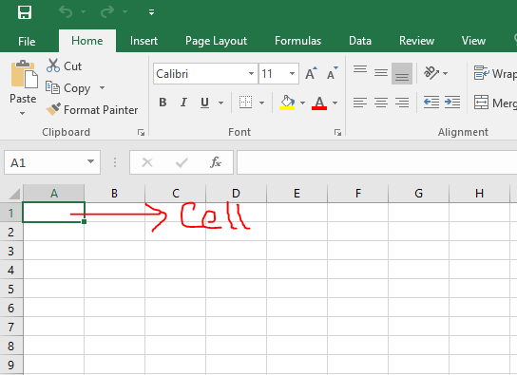

1. How can you restrict someone from copying a cell from your worksheet?

Ans: To restrict someone from copying following steps need to follow:

1. Open the Excel and Go to REVIEW tab and click on "Protect Sheet" option.
2. Excel opens the Protect Sheet dialog box. By default, Excel selects the Protect Worksheet and Contents of Locked Cells check box. Put password and then OK.
3. Optional: Select any of the check boxes in the Allow All Users of This Worksheet To list box (such as Format Cells or Insert Columns) that you still want to be functional when the worksheet protection is operational.

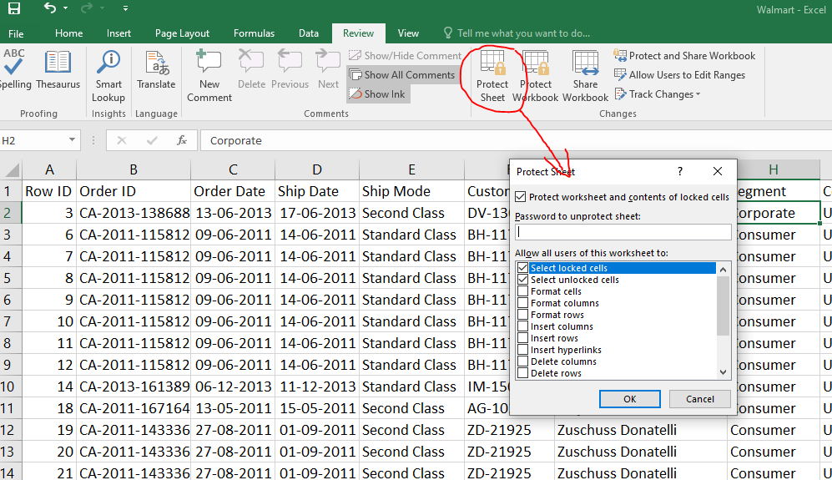

1. How to move or copy the worksheet into another workbook?

Ans:

To move the steps are follows:

1. Just click on the tab that has the sheet name on it.
2. Then hold your mouse button down while you drag it over.
3. And then release it wherever you want it to go in the new workbook.



To copy the steps are follows:

1. To **create a copy**, the process is identical to the one above, except before releasing the mouse button in the new sheet, you are going to **hold down the**Ctrl**key**.



This leaves a **duplicate** sheet in both workbooks.

**Note: The plus symbol (+) in the mouse cursor icon must appear when the sheet copied.

1. Which key is used as a shortcut for opening a new window document?

Ans: **Ctrl + N** is used as shortcut for opening a new window document. **Note: This key is used in Any spreadsheet as well documents and browser.

1. What are the things that we can notice after opening the Excel interface?

Ans: The things we can notice after opening the excels are

* Title bar. The title bar displays both the name of the application and the name of the spreadsheet.
* Menu bar. The menu bar displays all of the menus available for use in Excel XP. ...
* Column headings. ...
* Row headings. ...
* Name box. ...
* Formula bar. ...
* Cell. ...
* Navigation buttons and sheet tabs.

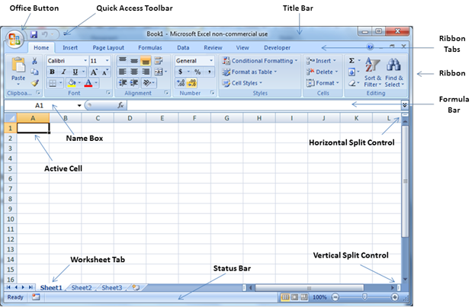

1. When to use a relative cell reference in excel?

Ans: Relative reference is a type of cell reference in Excel. This reference changes when the formula is copied to any other cell or any other worksheet. Relative cell references are used **whenever calculations need to be repeated**.

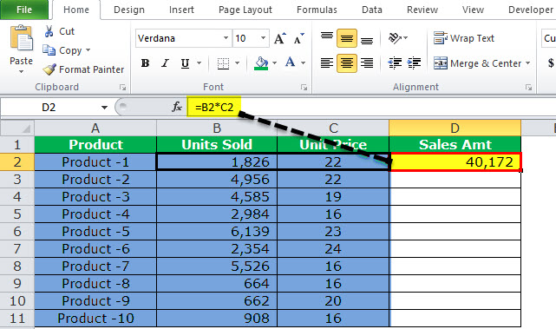

As in picture as we can see the formula is “=B2+C2”; so for the next column will be “=B3+C3” and so on.